Grove - I2C Color Sensor

(Redirected from [Twig - I2C Color Sensor v0.9b](http://www.seeedstudio.com/wiki/index.php?title=Twig_-_I2C_Color_Sensor_v0.9b&redirect=no))

|  |
| --- |
| **Contents**   [[hide](javascript:toggleToc())]   * [1 Introduction](http://www.seeedstudio.com/wiki/index.php?title=Twig_-_I2C_Color_Sensor_v0.9b#Introduction) * [2 Features](http://www.seeedstudio.com/wiki/index.php?title=Twig_-_I2C_Color_Sensor_v0.9b#Features) * [3 Application Ideas](http://www.seeedstudio.com/wiki/index.php?title=Twig_-_I2C_Color_Sensor_v0.9b#Application_Ideas) * [4 Specification](http://www.seeedstudio.com/wiki/index.php?title=Twig_-_I2C_Color_Sensor_v0.9b#Specification)   + [4.1 Key Specification](http://www.seeedstudio.com/wiki/index.php?title=Twig_-_I2C_Color_Sensor_v0.9b#Key_Specification)   + [4.2 Electronic Characterstics](http://www.seeedstudio.com/wiki/index.php?title=Twig_-_I2C_Color_Sensor_v0.9b#Electronic_Characterstics) * [5 Usage](http://www.seeedstudio.com/wiki/index.php?title=Twig_-_I2C_Color_Sensor_v0.9b#Usage) * [6 Reference](http://www.seeedstudio.com/wiki/index.php?title=Twig_-_I2C_Color_Sensor_v0.9b#Reference) * [7 Version Tracker](http://www.seeedstudio.com/wiki/index.php?title=Twig_-_I2C_Color_Sensor_v0.9b#Version_Tracker) * [8 Resources](http://www.seeedstudio.com/wiki/index.php?title=Twig_-_I2C_Color_Sensor_v0.9b#Resources) * [9 Support](http://www.seeedstudio.com/wiki/index.php?title=Twig_-_I2C_Color_Sensor_v0.9b#Support) |

Introduction

This module is based on the color sensor TCS3414CS with digital output I2C. Based on the 8*2 array of filtered photodiodes and 16-bit analog-to-digital converters, you can measure the color chromaticity of ambient light or the color of objects. Of the 16 photodiodes, 4 have red filters, 4 have green filters, 4 have blue filters and 4 have no filter(clear). With the synchronization input pin, an external pulsed light source can provide precise synchronous conversion control.

Model:[SEN60256P](http://www.seeedstudio.com/depot/grove-i2c-color-sensor-p-854.html?cPath=144_148)

[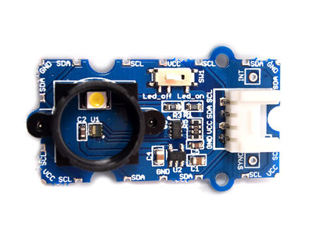](http://www.seeedstudio.com/wiki/File:I2C_Color_Sensor.jpg)

Features

* Grove compatible interface
* 16-Bit Digital Output with I 2C at 400 kHz
* SYNC Input Synchronizes Integration Cycle to Modulated Light Sources
* Operating Temperature Range -40℃ to 85℃
* Programmable Interrupt Function with User-Defined Upper and Lower Threshold Settings

Application Ideas

* Ambient light sensing
* Object color sensing
* Consumer Toys
* Industrial Process Control
* Tablets, Laptops, Monitors
* HDTVs

Specification

**Key Specification**

|  |  |
| --- | --- |
| **Items** | **Min** |
| PCB Size | 2.0cm*4.0cm |
| Interface | 2.0mm pitch pin header |
| IO Structure | SCL,SDA,VCC,GND |
| ROHS | YES |

**Electronic Characterstics**

|  |  |  |  |  |  |
| --- | --- | --- | --- | --- | --- |
| **Items** | **Conditions** | **Min** | **Norm** | **Max** | **Unit** |
| VCC | - | 3.3 | 5.0 | 6.0 | Volts |
| Current Draw | VCC=5V,Led On,Sensor Power on | - | 16 | - | mA |
| VCC=5V,Led On,Sensor Power Down | - | 8 | - | mA |
| VCC=5V,Led Off,Sensor Power On | - | 10 | - | mA |
| VCC=5V,Led Off,Sensor Power Down | - | 700 | - | μA |
| Operating Free-air Temperature | Ambient | -40 | - | 85 | °C |

Usage

This module can be used to detect the color of light source or the color of objects. When used to detect the color of the light source, the led switch should be turned off, and the light source should shine the sensor directly. When used to detect the color of things, the led should be on and you should put the object on the top of the enclosure closely. The theory of sensing the color of objects is Reflective Sensing Theory. Like the picture below.

[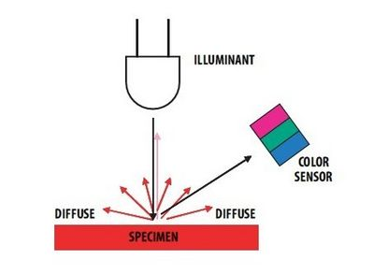](http://www.seeedstudio.com/wiki/File:Reflcect.jpg)

The following sketch demonstrates a simple application of sensing the color of the paper.

* Connect the Color Sensor to Seeeduino through the [Grove-Base Shield](http://www.seeedstudio.com/wiki/Grove_-_Base_Shield) using the I²C interface.
* Connect the Seeeduino to PC via a USB cable.

(图片)

* Copy and paste code below to a new Arduino sketch.

/******************************************************************************/

#include <Wire.h>

#include <math.h>

#define COLOR_SENSOR_ADDR 0x39//the I2C address for the color sensor

#define REG_CTL 0x80

#define REG_TIMING 0x81

#define REG_INT 0x82

#define REG_INT_SOURCE 0x83

#define REG_ID 0x84

#define REG_GAIN 0x87

#define REG_LOW_THRESH_LOW_BYTE 0x88

#define REG_LOW_THRESH_HIGH_BYTE 0x89

#define REG_HIGH_THRESH_LOW_BYTE 0x8A

#define REG_HIGH_THRESH_HIGH_BYTE 0x8B

#define REG_BLOCK_READ 0xCF

#define REG_GREEN_LOW 0xD0

#define REG_GREEN_HIGH 0xD1

#define REG_RED_LOW 0xD2

#define REG_RED_HIGH 0xD3

#define REG_BLUE_LOW 0xD4

#define REG_BLUE_HIGH 0xD5

#define REG_CLEAR_LOW 0xD6

#define REG_CLEAR_HIGH 0xD7

#define CTL_DAT_INIITIATE 0x03

#define CLR_INT 0xE0

//Timing Register

#define SYNC_EDGE 0x40

#define INTEG_MODE_FREE 0x00

#define INTEG_MODE_MANUAL 0x10

#define INTEG_MODE_SYN_SINGLE 0x20

#define INTEG_MODE_SYN_MULTI 0x30

#define INTEG_PARAM_PULSE_COUNT1 0x00

#define INTEG_PARAM_PULSE_COUNT2 0x01

#define INTEG_PARAM_PULSE_COUNT4 0x02

#define INTEG_PARAM_PULSE_COUNT8 0x03

//Interrupt Control Register

#define INTR_STOP 40

#define INTR_DISABLE 0x00

#define INTR_LEVEL 0x10

#define INTR_PERSIST_EVERY 0x00

#define INTR_PERSIST_SINGLE 0x01

//Interrupt Souce Register

#define INT_SOURCE_GREEN 0x00

#define INT_SOURCE_RED 0x01

#define INT_SOURCE_BLUE 0x10

#define INT_SOURCE_CLEAR 0x03

//Gain Register

#define GAIN_1 0x00

#define GAIN_4 0x10

#define GAIN_16 0x20

#define GANI_64 0x30

#define PRESCALER_1 0x00

#define PRESCALER_2 0x01

#define PRESCALER_4 0x02

#define PRESCALER_8 0x03

#define PRESCALER_16 0x04

#define PRESCALER_32 0x05

#define PRESCALER_64 0x06

int readingdata[20];

int i,green,red,blue,clr,ctl;

double X,Y,Z,x,y,z;

void setup()

{

Serial.begin(9600);

Wire.begin(); // join i2c bus (address optional for master)

}

void loop()

{

setTimingReg(INTEG_MODE_FREE);//Set trigger mode.Including free mode,manually mode,single synchronizition mode or so.

setInterruptSourceReg(INT_SOURCE_GREEN); //Set interrupt source

setInterruptControlReg(INTR_LEVEL|INTR_PERSIST_EVERY);//Set interrupt mode

setGain(GAIN_1|PRESCALER_4);//Set gain value and prescaler value

setEnableADC();//Start ADC of the color sensor

while(1)

{

readRGB();

calculateCoordinate();

delay(1000);

clearInterrupt();

}

}

/************************************/

void setTimingReg(int x)

{

Wire.beginTransmission(COLOR_SENSOR_ADDR);

Wire.write(REG_TIMING);

Wire.write(x);

Wire.endTransmission();

delay(100);

}

void setInterruptSourceReg(int x)

{

Wire.beginTransmission(COLOR_SENSOR_ADDR);

Wire.write(REG_INT_SOURCE);

Wire.write(x);

Wire.endTransmission();

delay(100);

}

void setInterruptControlReg(int x)

{

Wire.beginTransmission(COLOR_SENSOR_ADDR);

Wire.write(REG_INT);

Wire.write(x);

Wire.endTransmission();

delay(100);

}

void setGain(int x)

{

Wire.beginTransmission(COLOR_SENSOR_ADDR);

Wire.write(REG_GAIN);

Wire.write(x);

Wire.endTransmission();

}

void setEnableADC()

{

Wire.beginTransmission(COLOR_SENSOR_ADDR);

Wire.write(REG_CTL);

Wire.write(CTL_DAT_INIITIATE);

Wire.endTransmission();

delay(100);

}

void clearInterrupt()

{

Wire.beginTransmission(COLOR_SENSOR_ADDR);

Wire.write(CLR_INT);

Wire.endTransmission();

}

void readRGB()

{

Wire.beginTransmission(COLOR_SENSOR_ADDR);

Wire.write(REG_BLOCK_READ);

Wire.endTransmission();

Wire.beginTransmission(COLOR_SENSOR_ADDR);

Wire.requestFrom(COLOR_SENSOR_ADDR,8);

delay(500);

if(8<= Wire.available()) // if two bytes were received

{

for(i=0;i<8;i++)

{

readingdata[i]=Wire.read();

//Serial.println(readingdata[i],BIN);

}

}

green=readingdata[1]*256+readingdata[0];

red=readingdata[3]*256+readingdata[2];

blue=readingdata[5]*256+readingdata[4];

clr=readingdata[7]*256+readingdata[6];

Serial.println("The RGB value and Clear channel value are");

Serial.println(red,DEC);

Serial.println(green,DEC);

Serial.println(blue,DEC);

Serial.println(clr,DEC);

}

void calculateCoordinate()

{

X=(-0.14282)*red+(1.54924)*green+(-0.95641)*blue;

Y=(-0.32466)*red+(1.57837)*green+(-0.73191)*blue;

Z=(-0.68202)*red+(0.77073)*green+(0.56332)*blue;

x=X/(X+Y+Z);

y=Y/(X+Y+Z);

if((X>0)&&(Y>0)&&(Z>0))

{

Serial.println("The x,y value is");

Serial.print("(");

Serial.print(x,2);

Serial.print(" , ");

Serial.print(y,2);

Serial.println(")");

Serial.println("Please reference the figure(Chromaticity Diagram) in the wiki ");

Serial.println("so as to get the recommended color.");

}

else

Serial.println("Error,the value overflow");

}

* Upload the code, Please click [here](http://www.seeedstudio.com/wiki/Upload_Code) if you do not know how to upload.
* Open the serial monitor, You will see the output result of Color Sensor as show below:

[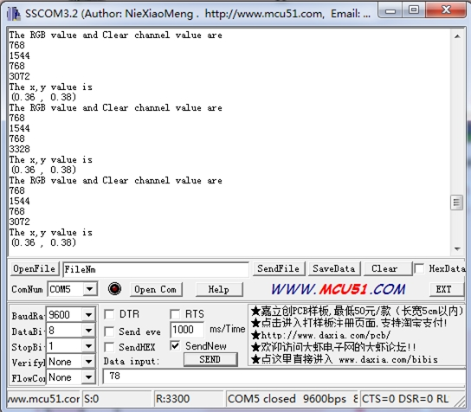](http://www.seeedstudio.com/wiki/File:I2C_Color_Sensor_Result.jpg)

* When we get coordinates (x, y), Please reference the below figure so as to get the recommended color.

[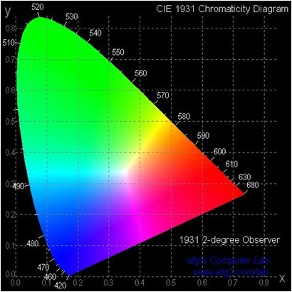](http://www.seeedstudio.com/wiki/File:Chromaticity_Diagram.jpg)

Reference

This module is based on the color sensor TCS3414CS. The TCS3414CS digital color sensor returns data from four channels: red(R), green(G), blue(B) and clear(C)(non-filtered). The response from the red, green and blue channels (RGB) can be used to determine a particular source’s chromaticity coordinates (x, y). These standards are set by the Commission Internationale de l’Eclairage (CIE). The CIE is the main international organization concerned with color and color measurement.In order to acquire the color of a given object using TCS3414CS, we must first map the sensor response (RGB) to the CIE tristimulus values (XYZ). It is then necessary to calculate the chromaticity coordinates (x, y).

[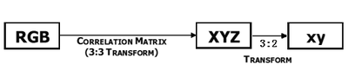](http://www.seeedstudio.com/wiki/File:Coordinates_transform.png)

[http://www.seeedstudio.com/wiki/skins/common/images/magnify-clip.png](http://www.seeedstudio.com/wiki/File:Coordinates_transform.png)

Chromaticity Calculation Process Overview

The equations to do the transformation:

[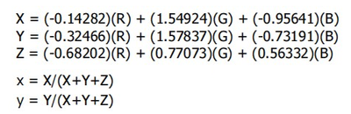](http://www.seeedstudio.com/wiki/File:Equations.png)

[http://www.seeedstudio.com/wiki/skins/common/images/magnify-clip.png](http://www.seeedstudio.com/wiki/File:Equations.png)

Transformation Equations

Version Tracker

|  |  |  |
| --- | --- | --- |
| **Revision** | **Descriptions** | **Release** |
| v0.9b | Initial public release | date |

Resources

* [Grove-I2C Color Sensor Eagle File](http://www.seeedstudio.com/wiki/File:Twig_-_I2C_Color_sensor_v0.9b_eagle_files.zip)
* [TCS3414-A Datasheet](http://www.seeedstudio.com/wiki/File:TCS3404_TCS3414-A.pdf)